**Serial Position Effect**

## Akashdeep S

## 181IT203

Link to the **live interactive website built** to analyse the results: <https://akashdeeps19.github.io/hci/lab1/index.html>

## Problem Statement:

Prepare a list of 8 to 10 animals. Read this list sequentially and slowly to your friends within a stipulated time. Then ask them to recall the items in the list freely. Record the recall frequencies of these words. Analyze whether the recall % varies with the position of each item within the list? Does the behaviour change for each individual? Does it have something to do with the individual's favourite animal? What is the general trend

## Procedure:

To analyse the serial position effect, I built an interactive website which would display a list of animals for 8 seconds and then the participants were asked to input the animals that they could recall. The inputs collected from this website were analysed together to draw the results and conclusions listed below.

## Results and Analysis:

## The demonstration was shown to 12 people and the recall frequencies were observed as follows:

|  |  |
| --- | --- |
| **Person** | **Recall Frequencies in %** |
| 1 | 62.5 |
| 2 | 37.5 |
| 3 | 50 |
| 4 | 62.5 |
| 5 | 50 |
| 6 | 25 |
| 7 | 37.5 |
| 8 | 25 |
| 9 | 50 |
| 10 | 75 |
| 11 | 37.5 |
| 12 | 62.5 |

The following inferences can be made from the observations:

* 1. The serial position effect was clearly seen as the majority failed to recall the animals in the middle. The first and last animals were recalled by almost everyone.
* 2. Cat and dog are common animals and hence were recalled by everyone. Koala bear is an extinct animal that not many people are aware of. Hence it was recalled by just one person out of the 12.
* 3. The average recall percentage was around 40%. The highest recall percentage was 75%. And the lowest was 25%. The person who scored the lowest score was only able to recall "cat" and "dog".
* 4. Majority seemed to recall their favorite animal even if the animal wasn't at the start or the end of the list. This was an interesting observation made in an experiment designed to demonstrate the serial position effect.

Screenshots:

1) Instructions Screen

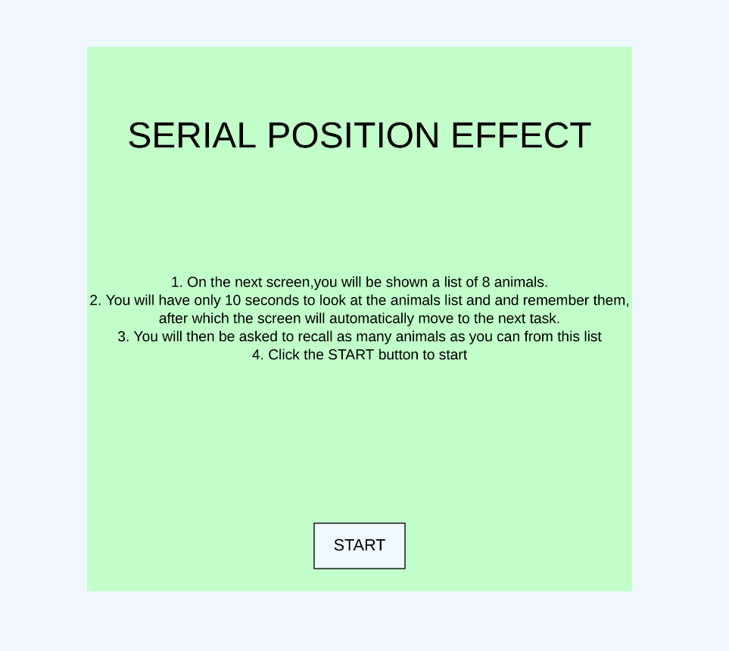

2) List of 8 animals displayed for 8 seconds

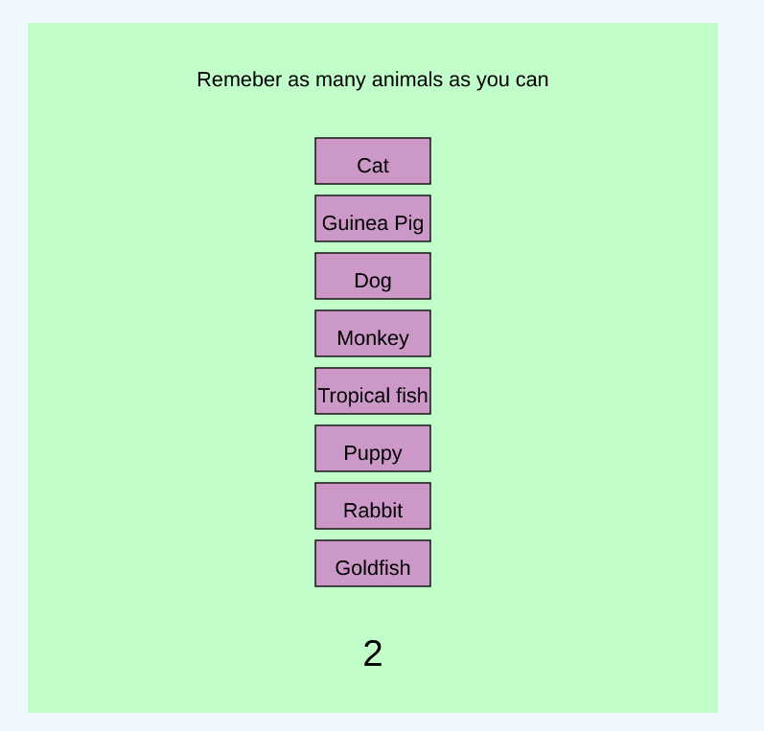

3) The page where the user can select the animals from the previously displayed list. The recall percentage is displayed once the “Done” button is clicked.

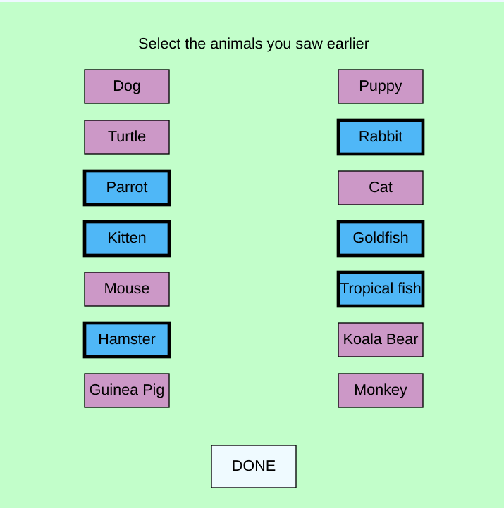

4) The Inferences that can be made from the results are displayed in this page

